**9)**

**CODE:**

<!DOCTYPE html>

<html>

<head>

<style>

table, th, td {

border: 1px solid black;

border-collapse: collapse;

}

</style>

</head>

<body>

<center>

<table >

<tr>

<th>Product ID</th>

<th>Product Name</th>

<th>Product Quality</th>

<th>Product Quantity</th>

</tr>

<tr>

<td>1</td>

<td>Wheat</td>

<td>Good</td>

<td>200 Bags</td>

</tr>

<tr>

<td>2</td>

<td>Rice</td>

<td>Good</td>

<td>250 Bags</td>

</tr>

<tr>

<td>3</td>

<td>Sugar</td>

<td>Good</td>

<td>200 Bags</td>

</tr>

</table>

</center>

<P> SUDANA SHASHI KIRAN 21BCE8644 </P>

</body>

</html>

**OUTPUT:**

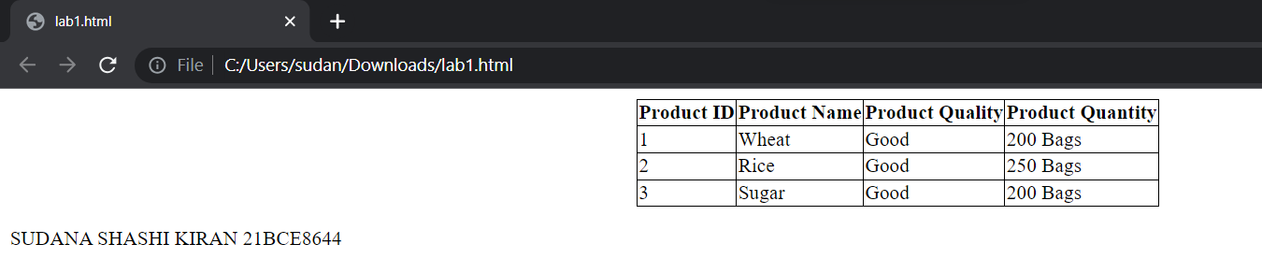

**10)**

**CODE:**

<!DOCTYPE html>

<html>

<head>

<style>

table, th, td {

border: 1px solid black;

border-collapse: collapse;}

</style>

</head>

<body>

<center>

<table >

<tr>

<th>Search engine</th>

<th>Total found</th>

<th>Primary selected</th>

<th>Final selection</th>

</tr>

<tr>

<th>Spinger link</th>

<td>2230</td>

<td>280</td>

<td>33</td>

</tr>

<tr>

<th>ACM</th>

<td>877</td>

<td>110</td>

<td>15</td>

</tr>

<tr>

<th>Google Scholar</th>

<td>710</td>

<td>60</td>

<td>06</td>

</tr>

<tr>

<th>Science Direct</th>

<td>612</td>

<td>56</td>

<td>06</td>

</tr>

<tr>

<th>Total</th>

<td>5732</td>

<td>716</td>

<td>116</td>

</tr>

</table>

</center>

</body>

<P> SUDANA SHASHI KIRAN 21BCE8644 </P>

</html>

**OUTPUT:**

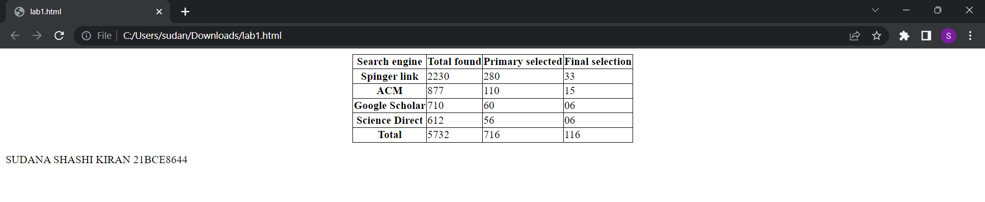

**11)**

**HTML FORM:**

**CODE:**

<!DOCTYPE html>

<html lang="en">

<head>

<meta charset="UTF-8">

<meta http-equiv="X-UA-Compatible"

content="IE=edge">

<meta name="viewport"

content="width=device-width, initial-scale=1.0">

<title>GfG</title>

</head>

<body>

<form>

<fieldset>

<legend>Personal Details</legend>

<p>

<label>

Salutation

<br />

<select name="salutation">

<option>--None--</option>

<option>Mr.</option>

<option>Ms.</option>

<option>Mrs.</option>

<option>Dr.</option>

<option>Prof.</option>

</select>

</label>

</p>

<p>

<label>First name: <input name="firstName" /></label>

</p>

<p>

<label>Last name: <input name="lastName" /></label>

</p>

<p>

Gender :

<label><input type="radio" name="gender"

value="male" />

Male

</label>

<label><input type="radio" name="gender"

value="female" />

Female

</label>

</p>

<p>

<label>Email:<input type="email"

name="email" />

</label>

</p>

<p>

<label>Date of Birth:<input type="date"

name="birthDate">

</label>

</p>

<p>

<label>

Address :

<br />

<textarea name="address" cols="30"

rows="3">

</textarea>

</label>

</p>

<p>

<button type="submit">Submit</button>

</p>

</fieldset>

</form>

<P> SUDANA SHASHI KIRAN 21BCE8644 </P>

</body>

</html>

**OUTPUT:**

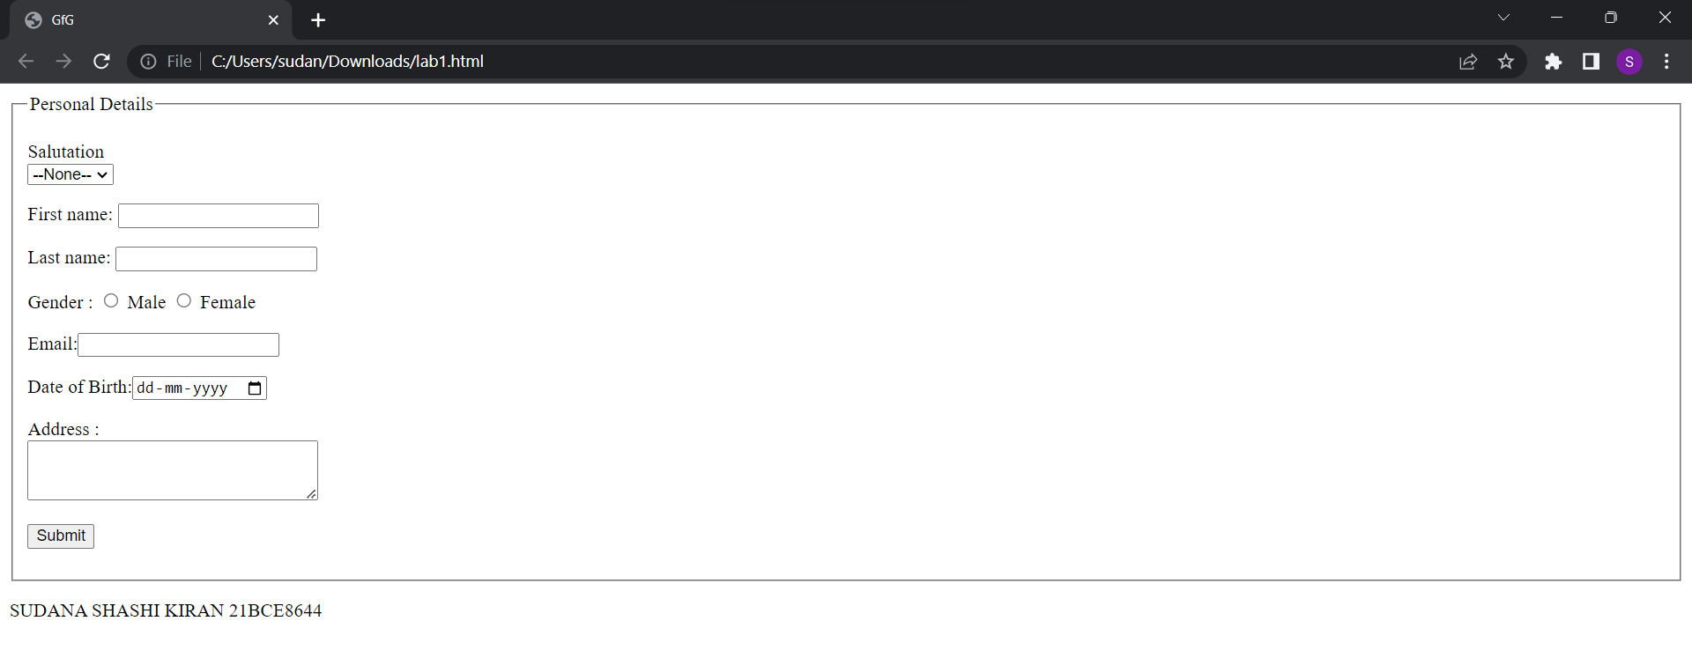

**12)HTML SMALL FORM :**

**CODE:**

<!DOCTYPE html>

<html>

<body>

<h2>HTML Forms</h2>

<form action="/action_page.php">

<label for="fname">First name:</label>&emsp;&ensp;

<input type="text" id="fname" name="fname"><br><br>

<label for="lname">Last name:</label>&emsp;&ensp;&nbsp;

<input type="text" id="lname" name="lname"><br><br>

<lable for="dob">Date Of Birth:</lable>&nbsp;

<input type="number" id="DOB" name="Date Of Birth"/><br><br>

<label for="email">Email: </label>&emsp;&emsp;&emsp;&nbsp;

<input type="email" id="email" name="Email"/><br><br>

<lable for="mobile.no">Mobile number:</lable>

<input type="mobile.no" id="mobile.no" name="Mobile number"/><br><br><br>&emsp;

<input type="submit" value="SUBMIT">&emsp;&emsp;&emsp;&emsp;&emsp;&emsp;&emsp;

<input type="reset" value="RESET">

</form>

<P> SUDANA SHASHI KIRAN 21BCE8644 </P>

</body>

</html>

**OUTPUT:**

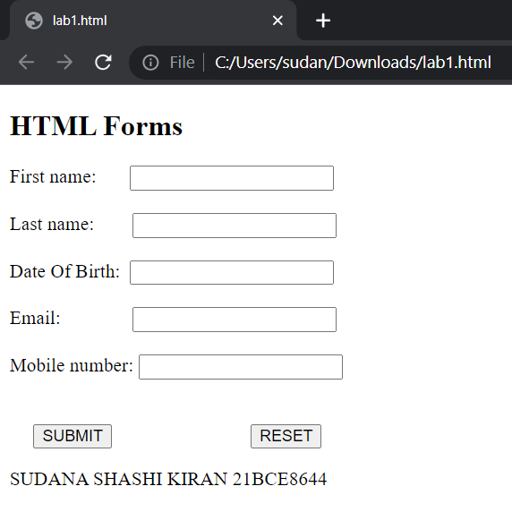

**13)HTML BIG FORM :**

**CODE:**

<!DOCTYPE html>

<html>

<body style="background-color:#61ffff;">

<form action="/action_page.php">

<label for="fname">First name:</label>&emsp;&ensp;

<input type="text" id="fname" name="fname"><br><br>

<label for="mname">Middle name:</label>&ensp;

<input type="text" id="mname" name="mname"><br><br>

<label for="lname">Last name:</label>&emsp;&ensp;&nbsp;

<input type="text" id="lname" name="lname"><br><br>

<label for="register_country" class="label">Select Country:</label>

<select name="country" id="register_country" style="width:160px">

<option value="india">india</option>

<option value="USA">USA</option>

<option value="UK">UK</option>

<option value="china">china</option>

<option value="other">other</option>

</select><br><br>

<label for="Gender">Gender:</label><br>

<input type="radio" id="male" name="Gender" value="Male">

<label for="male">Male</label><br>

<input type="radio" id="male" name="Gender" value="Female">

<label for="female">Female</label><br>

<input type="radio" id="other" name="Gender" value="Other">

<label for="other">Other</label><br><br>

<label for="phone">Phone: </label>

<select name="phone" id="phone_numper" style="width:45px">

<option value="+91">+91</option>

<option value="+1">+1</option>

<option value="+44">+44</option>

<option value="+86">+86</option>

<option value="other">other</option>

</select>

<input type="number" id="phone" name="Phone"/><br><br>

<label for="address">Address: </label><br>

<textarea rows="4" cols="60"></textarea><br><br>

<label for="email">Email: </label>

<input type="email" id="email" name="Email"/><br><br>

<lable for="password">Password:</lable>

<input type="password" id="password" name="Password"/><br><br>

<lable for="Re-enter password">Re-enter password:</lable>

<input type="password" id="re-enter assword" name="Re-enter password"/><br><br><br>

<input type="submit" value="SUBMIT">

</form>

<p> SUDANA SHASHI KIRAN 21BCE8644 </P>

</body>

</html>

**OUTPUT:**

